**High level Architecture Design Diagram for the Location based Taxi Aggregator and Selector (Cloud)**

**Demo Presentation:**

1. Delete existing DB if present

1. Connect to Ec2 instance using below command from terminal

ssh -i "ec2cp2.pem" [ubuntu@ec2-3-143-22-60.us-east-2.compute.amazonaws.com](mailto:ubuntu@ec2-3-143-22-60.us-east-2.compute.amazonaws.com)

1. Run InitializeTaxiAggregatorDB.py to create DB, Collections and 2dsphere index and then insert default service area location.

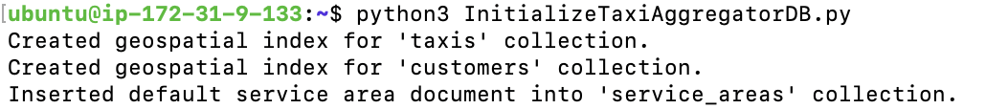

1. Run RegisterTaxis.py to create 50 sample taxi data.

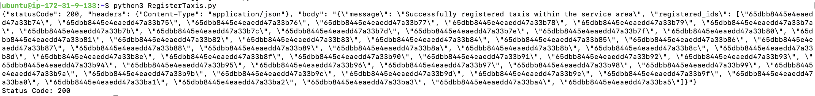

1. Run RegisterCustomers.py to create 5 sample Customer data.

1. Run TaxiLocationUpdateSimulator.py to send location data for different taxis at regular interval.

1. Post below request in postman to find rides based on customer location proximity search. API - <https://udmqfurfie.execute-api.us-east-2.amazonaws.com/dev/ride/find>

{

"location": {

"type": "Point",

"coordinates": [77.23149, 28.61123]

},

"type": "Luxury"

}

1. Post below json request to create a taxi data using API - <https://udmqfurfie.execute-api.us-east-2.amazonaws.com/dev/taxi>

{

"name": "Taxi_052",

"type": "Luxury",

"location": {

"type": "Point",

"coordinates": [

78.3368142118244,

27.66077927262116

]

}

}

{"name": "Taxi_052"} find result:

9. Post below json request to create a customer data using API - <https://udmqfurfie.execute-api.us-east-2.amazonaws.com/dev/customer>

{

"name": "Manju",

"location": {

"type": "Point",

"coordinates": [

77.24098,

28.65454

]

}

}

{"name": "Manju"} find result:

1. Service area validation for customer. Post below request to API (<https://udmqfurfie.execute-api.us-east-2.amazonaws.com/dev/customer> ) to test this.

{

"name": "Manju",

"location": {

"type": "Point",

"coordinates": [

87.24098,

28.65454

]

}

}

1. Service area validation for taxi. Post below request to API - https://udmqfurfie.execute-api.us-east-2.amazonaws.com/dev/taxi to test this.

{

"name": "Taxi_052",

"type": "Luxury",

"location": {

"type": "Point",

"coordinates": [

78.3368142118244,

37.66077927262116

]

}

}

**EC2 instance:**

**API Gateway:**

**Lambda Functions:**

**Taxi Registration Lambda:**

**Customer/User registration Lambda:**

**Ride Find Lambda:**

**Docker instance running in EC2:**

